ePROCUREMENT CHECKLIST
SPECIAL REQUEST
Item Details

- Item Description-this is your line item, should be the same as your quote. Make sure it is very descriptive. By putting a description of product or service helps to identify when you are inquiring on your requisition, no acronyms if possible. (Ex: Conference room chairs #Product 12345 for Budget & Finance) Make sure you are adding as many lines as your quote.
- Price-please proof read to make sure the price and quantity has not been transposed
- Quantity
- Unit of Measure-use EA
- Category Field Enter 5 ZEROS (00000) (putting any number other than 00000 will put your requisition in budget error)
- Supplier Name Click magnifying glass to locate Supplier’s name under Short Supplier Name (click find). For New Supplier or Update Existing Supplier, please follow the instructions Please verify you have entered the correct supplier.
- Additional Information **REQUIRED**
- CSU Contact Name
- Phone Number
- Department
- Location where product should be delivered
- Quote #/Proposal #/Statewide Contract #
- Completion Date of service (NEW)
- √ “Send to Supplier” Box
- √ Add to Cart
- .√ Checkout (at top of page)

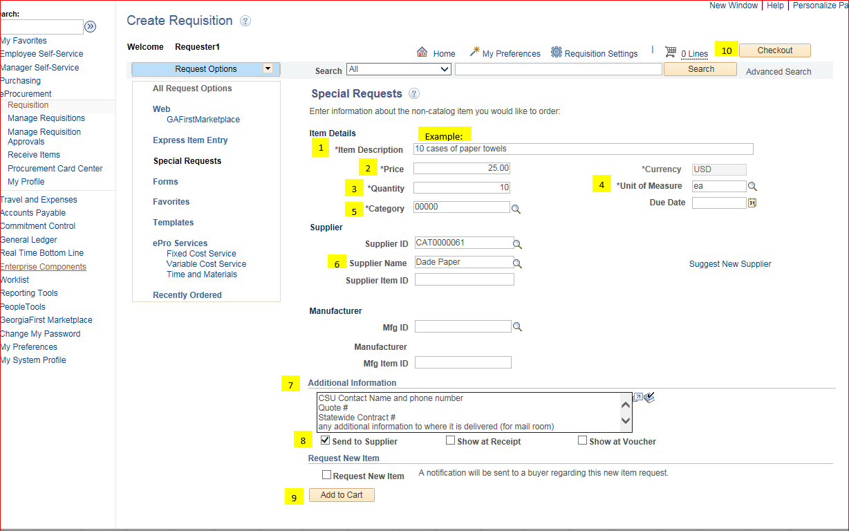

SPECIAL REQUEST cont’d
Requisition Summary
11. Requisition Name- description of purchase/service (Please name your requisition, it makes it easier to locate under “manage requisitions”)
Cart Summary
- Add Attachments attach file under comments on line item (bubble)
Supporting Documents to Attach
- Final Contract, if it went through contract review (if applicable)
- Contractor’s Affidavit (> $2,500.00)
- Current Quote - not invoice
- Construction Contract (if applicable)
- Certificate of Insurance Eligibility (COI) if vendor performs service on campus

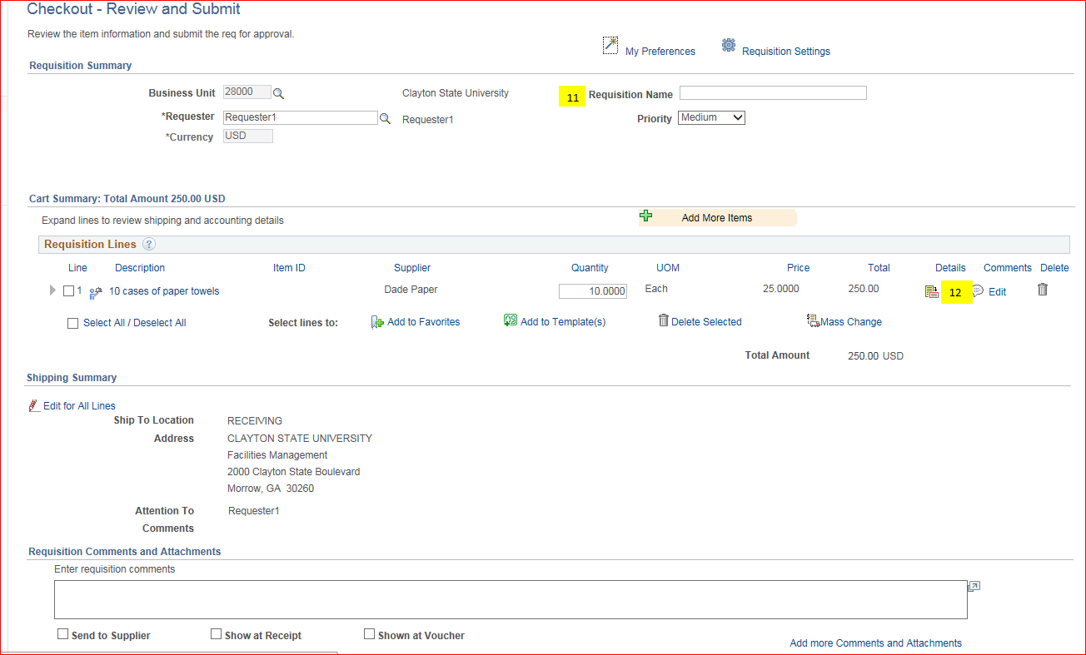

- Accounting Lines
- Chart field 2, enter Fund Code, Department, Program, Class and Project. Please verify accounting string is correct
- Chart field 3 (if project ID is required)
- Asset Information (if product is asset-single item over $3000.00) Enter AM Business Unit Field 28000 and Profile ID

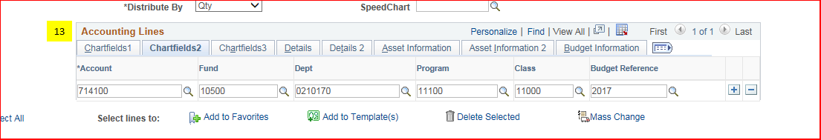

Approval Justification

- Justification/Comments Field **REQUIRED**-put detailed business purpose for product/service.
Save & Submit
